**Break Keyword**

break is an optional keyword used to stop executing the code and skip all statements located after it. In other words its terminate the loop.

break statements is used inside two statements:

1. Looping statements.
2. Switch keyword.

Syntax of break keyword is: break;

If the loop you want to break has a label then break syntax will be: break loop-label;

**Example1:**

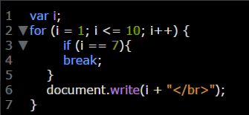

**Example2:** the same previous example but with another if shape.

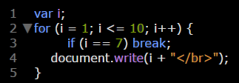

**Example3:**

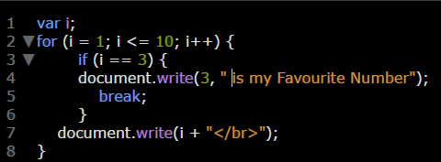

**Example 4:** using break keyword with switch statement.

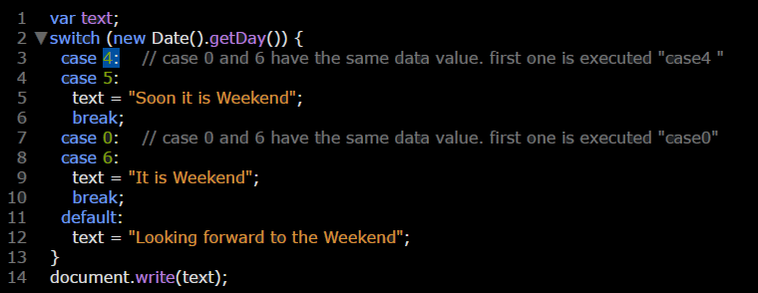

**Example 5:**

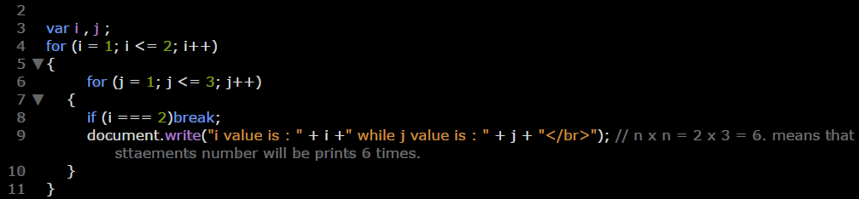

**Note:** in case of several loops if you break the father loop (oldest loop) the newest loops inside it will also break but the opposite isn’t true.

**Example 6:** in this example we break Father Loop so child loops will be break also.

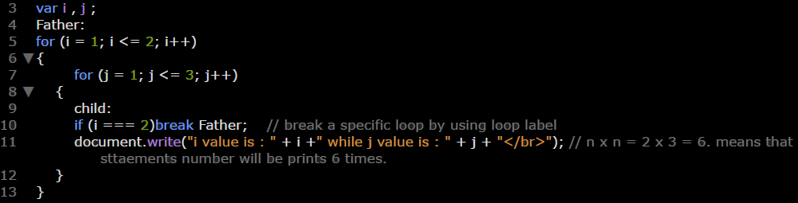

**Example 7:** in this example we break child Loop so Father Loop will not be break.

